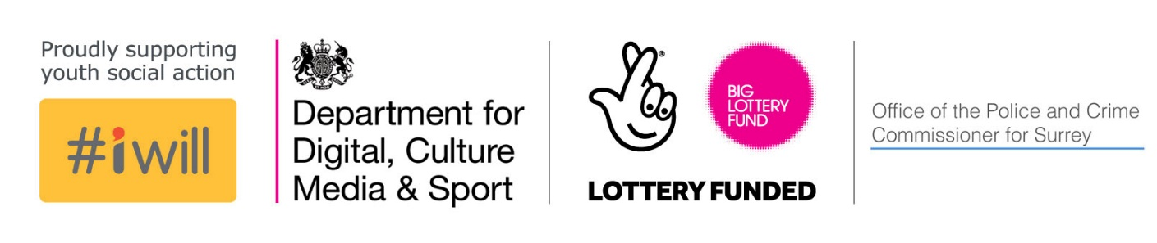

#iwill 2018

FUND CRITERIA AND GUIDANCE FOR APPLICANTS

A definition of youth social action:
‘Young people taking practical action in the service of others in order to create positive social change that is of benefit to the wider community as well as to the young person themselves.’
Young Foundation
Youth Social Action includes volunteering, fundraising and campaigning, as well as skills and confidence-building projects which work with young people, particularly from less affluent backgrounds, to develop an appetite for this sort of activity

What is the #iwillFund?
#iwill is a UK-wide campaign that aims to make social action part of life for as many 10 to 20 year-olds as possible by the year 2020. Through collaboration and partnership it is spreading the word about the benefits of youth social action.

aims
The programme aims to increase overall participation of young people in meaningful social action from 40% to 60% by 2020, with a particular focus on deprived areas.

Social action involves activities such as campaigning, fundraising and volunteering and has huge potential to create enjoyable opportunities and skills development for young people, and in turn benefit the local people and places.

Step Up To Serve, Big Lottery Fund and the Government Office for Civil Society have invested £2million this year to fund groups delivering youth social action opportunities. Community Foundations will match this investment.

The #iwillFund looks to support activities that create opportunities for young people aged 10-20 to develop their character and their capacity to significantly contribute to their community.

six principles of social action
Projects must demonstrate how they will apply all six principles of youth social action:
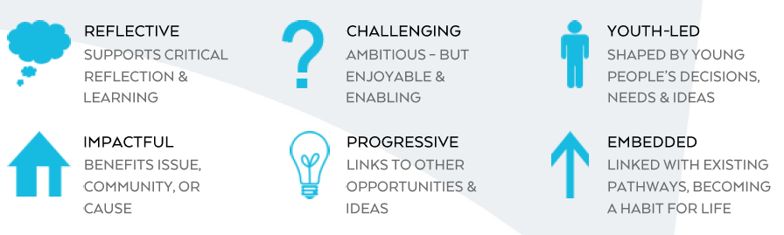

applying for a grant

Grants
- Grants are between £1,000 and £5,000.
- Projects can be up to a year in duration.
- Grants should deliver social action opportunities for young people age 10 to 20 years old, or 25 for disabled people.

Eligibility
- This fund is open to registered charities, constituted community groups and other charitable organisations including Social Enterprises and CICs in England.
- National organisations with local branches (with their own management committee and bank account) can apply.
- New organisations that can demonstrate they are financially robust can apply.

Priorities
We will prioritise projects that:
- Seek to increase participation from young people from less affluent social economic groups, hard to reach groups and people who might not usually take part in social action;
- Are working with young people at the younger end of the spectrum (10-14 years old)
- Build the appetite of young people to continue with social action; support habit forming behaviour; leave a legacy of behaviour/activity after the funding stops
- Involve young people in planning, delivery and evaluation.
- Give young people the opportunity to learn new skills and develop their character and confidence.
- Give young people the platform to get their voice heard.

This fund aims to develop opportunities rather than fund the provision of existing youth work. We are looking to fund organisations that support young people to thrive and where the involvement of young people in social action will improve the outcomes of the organisation.
Skills development projects, which help young people be ‘social action-ready’ are as valuable as existing project delivery itself.

What we will fund
- Staff costs - Budget for staffing, including full-time staff, part time staff and other related expenses
- Development and capacity building costs – Budget to help build capacity and sustainability of organisation e.g. staff/volunteer training, external consultancy fees.
- Volunteer costs - Budget for reimbursements of expenses, e.g. telephone calls, travel and meals.
- Activity costs - Budget for resources to facilitate a project / activity that fall outside capital, volunteer or staffing costs, e.g. catering, insurance.

what we won’t fund
- Statutory services
- Activities promoting party political activity
- Capital costs / large equipment costs – small scale equipment, such as tools are acceptable up to 10% of the requested grant
- Individual sponsorship
- Activities generating private profit
- Faith groups are welcome to apply but activities which evangelise or proselytise religious beliefs will not be eligible. Projects that only work with one faith are also not eligible.

governance
We will ask for the following documents to carry out due diligence on your organisation:
- A copy of your governing document (e.g. constitution, memorandum & articles or set of rules).
- A copy of your most recent annual accounts or management accounts.
- A photocopy of a bank statement no more than 3 months old. The bank account must be in the name of the organisation applying.
- Copies of your safeguarding and equal opportunities policies.
- A list of the names and addresses of your Trustees or management committee. You will need a minimum of three unrelated Trustees / management committee members.

